GIL-DONG HONG*, GIL-DONG KIM**, GILDONG LEE***, GIL-DONG PARK*
* Affiliation 1 in short form (Institution, City, Country)
** Affiliation 2 Use the superscripts (*, **) after the Author’s name in case of different affiliations
*** Affiliation 3 Use the superscripts (*, **) after the Author’s name in case of different affiliations

Characterization and cell performance of Al paste with an inorganic binder of Bi₂O₃–B₂O₃–ZnO system in Si solar cells (Title with all words in lower case)

Abstract
In this study, an eco-friendly Bi₂O₃–B₂O₃–ZnO glass frit without Pb was selected as an inorganic additive of Al paste for Si solar cell. The effect of glass chemistry on electrical property of Al electrode and cell performance was investigated. The results showed that as the molar ratio of the ZnO to B₂O₃ increased, the glass transition temperature (T_{g}) and its softening temperature (T_{s}) decreased due to the reduction of viscosity. In Al screen-printed Si solar cells, as the molar ratio of the ZnO to B₂O₃ increased, the sheet electrical resistance of Al electrode decreased and the cell efficiency was improved. Sintered microstructure showed that the uniformity and thickness of back surface field depended significantly on glass chemistry.

Keywords: Si solar cell, Al paste, Bi₂O₃–B₂O₃–ZnO glass, Al back contact (5 maximum)

Corresponding author: Dr. S.-S. Ryu
Tel.: +82-31-645-xxxx, Fax: +82-31-645-xxxx
E-mail: ssryu@xxxxx.re.kr
Engineering Ceramic Center, Korea Institute of Ceramic Engineering and Technology, 30 Gyeongchung Rd., Sindun-myeon, Icheon-si, Gyeonggi 467-843, Korea

1. Introduction

Many studies on solar cell have become active in the world to reduce production cost and overcome the limitations of efficiency of the existing solar cells [1,2]. Despite of enormous endeavor, the efficiency of commercial p-type silicon solar cells has been limited under 20%, which is only a marginal value for commercial applications [3]. Screen-printed crystalline silicon(c-Si) solar cells are widely used in the photovoltaic industry. A screen printing is a very useful process for the fabrication of electrodes.
Thick Al films are widely used as backside contact in single-crystalline or poly crystalline Si solar cells. Al electrodes are commonly formed by firing a printed layer formed by the screen printing method; the electrodes are formed by using Al paste containing Al powder, inorganic binder and a resin binder [4]. Pb-based glass frit having various superior characteristics such as sintering characteristics has been used as an inorganic binder. Al electrodes formed by firing at high temperatures serve as electrical contacts. Al is also used to create a back-surface field (BSF). A thick Al layer is alloyed with silicon during the firing of the contacts. The BSF reduces back-surface recombination and enhances efficiency [5].
A glass provides adhesion strength on Si cells and enhancing Al particle sintering, while it has a negative effect on electrical property due to its inherent insulation characteristic. Therefore, the selection of proper glass composition is very important. Conventional Al paste contains Pb-based glass such as PbO-B₂O₃ -SiO₂ system [6]. Recently, the solar cell industry is moving towards environmental-friendly materials, especially Al paste without Pb [7].
This study aims to produce the Al paste using eco-friendly glass frit without Pb for back contact of Si solar cells. For this objective, B₂O₃-Bi₂O₃-ZnO glass system was selected as an inorganic additive of Al paste. The effect of glass chemistry on an electrical resistance of Al electrode and the cell performance was investigated.

2. Experimental

In this study, Bi₂O₃–B₂O₃–ZnO glasses were obtained by traditional melting method. Reagent oxides of Bi₂O₃, B₂O₃ and ZnO were used as starting raw materials to prepare glass frits. Three kinds of glass composition were designed changing the molar ratio of ZnO to B₂O₃ in the glass forming range and the Al pastes with corresponding glass were prepared. The batch compositions of glass frits employed are presented in Table 1. Each batch was melted by using an alumina crucible after mixing in a turbula mixer for 1 h. Melting temperature was at 1200◦C and duration was fixed for 1 h. Molten glasses are quenched to form glass frit. Glass frit is milled in planetary mill for 2 h to obtain fine-sized glass powder. Glass powder obtained was characterized by dilatometer analysis and high temperature microscope.
Three different Al pastes were carefully formulated. The corresponding Al pastes with ZB1, ZB2 and ZB3 glass were designated as PZB1, PZB2 and PZB3, respectively. For each paste, the weight ratio of Al powder particles, glass powder and organic binder was invariable. 2 wt% of glass powder was mixed in Al powder. Dispersion of the Al and glass powders into an organic binder mixture was carried out using a 3 roll mill to fabricate screen-printable Al paste.
Screen-printed solar cells (6 in-15.6 cm²) were fabricated on mono-crystalline p type Si wafer using carefully controlled Al pastes and by IR belt furnace. The Si wafers were first chemically cleaned and wet etching, followed by diffusion of POCl₃ in a tube furnace to form the high-sheet-resistance n+ emitter. After the removal of phosphorus glass and a second-time hydrofluoric acid cleaning, plasma enhanced chemical vapor deposited (PECVD) SiNx anti-reflection coating was deposited on the emitter. Next, an Al paste was screen-printed on the rear side of the Si wafers and oven dried at 230◦C in 10 min. The Ag grids were then screen-printed on the top of the SiNx coating layer and oven dried at 230◦C in 10 min. Both the Ag and Al contacts were co-fired at 800◦C in an IR lamp-heated, five-zone and belt-line furnace. Cells were fired at 800 ◦C, which was actually measured peak temperature in the furnace atmosphere with a belt speed of 600 mm/sec in 60 sec. Finished cells were characterized by I–V analysis at standard operating condition of AM 1.5 (1000Wm−2) irradiance. Cell efficiency was determined by this test. Electrical sheet resistance was tested by 4 point probe method. Scanning electron microscope (SEM) (JEOL-JSM-6360LV, JAPAN) was investigated to identify the Al-Si reaction layer and samples were etched in a solution of HF-HNO₃-DI Water (= 1:2:3) for 15 sec.

3. Results and discussion

Table 1 lists the batch composition and the thermal properties of the glass frits used as an inorganic binder in this study. The thermal properties such as glass transition temperature (Tg) and softening temperature (Ts) were measured from the data curve obtained using the dilatometer. As shown in this table, Tg and Ts decreased with increasing ZnO content and ZB3 glass had the lowest Tg and Ts of 359ºC and 377ºC, respectively. It could be interpreted that when considering the equilibrium phase diagram of the Bi₂O₃–B₂O₃–ZnO ternary system, the eutectic temperature of glass decreased. This is attributed to the increase of ZnO as a network modifier in the structure as well as the non-bridging oxygen due to the reduction of B₂O₃ as a network former. As a result, Tg and Ts decreased through loosening of glass network structure.
TABLE 1. Experimental composition and properties of glass
Glass name | Composition (mol.%) |  |  |  | Thermal properties
 | Bi₂O₃ | ZnO | B₂O₃ | ZnO: B₂O₃ | Tg (℃) | Ts (℃)
ZB1 | 40 | 15 | 45 | 0.3 | 406 | 428
ZB2 | 40 | 25 | 35 | 0.7 | 383 | 407
ZB3 | 40 | 35 | 25 | 1.4 | 359 | 377

High temperature microscope was used to investigate wetting behavior of powder compact on Si wafer during heating. Fig. 1 shows the result of image observing geometry change of glass with different ZnO to B₂O₃ ratios which was recorded by high temperature microscope during heating. As shown in this figure, it is clear that the morphology of cylinder compact changed as the temperature increased, indicating that the viscosity of glass decreased gradually during heating-up. The sintering shrinkage and wetting on Si in ZB1 glass started at 500ºC and 600ºC, respectively, while ZB3 glass had the shrinkage temperature at 500ºC and wetting occurred at 550ºC. Shrinkage and wetting of glass depends significantly on its composition. In other words, As ZnO content increased, the temperatures occurring the shrinkage as well as wetting decreased. It can be proved that the increase in the content of ZnO made the glass structure more loosening and improved the wetting performance. It is expected that sintering of Al particle also could be enhanced when glass with lower softening glass was used.
Fig. 2 shows the efficiency of the cell and electrical sheet resistance of Al electrode as a function of the ratio of ZnO to B₂O₃. As show in this figure, the cell efficiency increased and electrical sheet resistance decreased with increasing ZnO content. In case of ZB3, the highest cell efficiency of 17.4 % and the lowest electrical sheet resistance of 18 mohm/ was obtained. In other words, Al film using glass powder with lower Tg and Ts possessed the lowest electrical sheet resistance and efficiency in a cell could be also improved. Therefore, thermal property of glass is the key factor for performance of cell.
Fig. 3 shows SEM surface morphology for screen-printed Al back contact with different glass compositions, i.e., the ZnO to B₂O₃ ratio after firing at 800ºC. In this figures, white region is a glass phase. Glass agglomeration was observed in PZB1 and PZB2 samples with the glass of higher B₂O₃ content. In case of PZB3 specimen, glass phase was well dispersed locating between Al-Al particles. This microstructure observation result seemed to be closely related to the viscosity change of glass during heating. It is well known that the addition of glass frit in the Al electrode enhance the contact between the Al particles. And also the good connectivity among Al particles is required for fabrication of Al electrode with good electrical conductivity, i.e., lower electrical resistance . Therefore, since glass agglomeration hinder connecting between Al particles, having a negative effect on the electrical sheet resistance. This is responsible for the increase in the electrical sheet resistance with decreasing ZnO content in glass composition, as can be seen in Fig. 2.
Fig. 4 shows cross sectional back scattered SEM images of the back surface of the as-sintered samples screen-printed with different ratios of ZnO to B₂O₃. Sample was etched in a solution of HF-HNO₃-H₂O for 15 sec. As shown in this figure, in all specimens, the various layers which are Al layer, Al-Si eutectic layer, heavily p-doped P+ region and Si substrate were clearly observed. The BSF layer became more uniform and its thickness increased with increasing the ZnO to B₂O₃ ratio. This might be closely related to glass property, i.e., thermal behavior of glass during heating. The lower softening point glass accelerated the sintering of Al particles due to lower viscosity [German], resulted in making BSF layer thicker and more uniform. Glass agglomeration was appeared in PZB1 and PZB2 samples of Fig. 3(a) and (b) with lower ZnO content. This might cause the non-uniformity of BSF layer, as shown in Fig. 4(a) and (b). As mentioned before, the back surface field, which is more uniform and thick, plays an importance the role in preventing the recombination of the electron hole of the back side. And it raises the effect of the passivation as well as the improvement the efficiency of the solar cell.

4. Conclusions

In this study, the corresponding Al pastes containing three kinds of glass composition which was designed changing the molar ratio of ZnO to B₂O₃ was prepared and their electrical property of Al electrode and cell performance was investigated. Thermal properties such as transition temperature softening point of glass depended significantly on the molar ratio of ZnO to B₂O₃. As the molar ratio of ZnO to B₂O₃ increased, electrical sheet resistance of Al electrode decreased and cell efficiency was improved. As the ZnO content increased, more uniform and thicker BSF layer was formed and also glass phase was well dispersed between Al particles.

Acknowledgments

REFERENCES

[1] L. L. Kazmerski, J. Electron Spectrosc., 150, 105 (2006).
[2] M. H. Kamdar, A.M.C. Westwood, Environment-Sensitive Mechanical Behaviour, New York 1981.
[3] F. E r d o g a n, in: H. Liebowitz (Ed.), Fracture 2, Academic Press 684, New York (1968).
[4] http://www.twi.co.uk/content/fswqual.html
[5] F.M. L I a n g. World Hyphenation by Computer. PhD thesis, Stanford University, Stanford, CA 94305, June.

Figure captions
Fig. 1. Shape change of Bi₂O₃–B₂O₃–ZnO glass powder compacts with different compositions as a function of temperature (heating rate of 50 ºC/min).
Fig. 2. Effect of the composition of glass frit on the cell efficiency and sheet resistance.
Fig. 3. Surface SEM microstructure of screen-printed Al back contact which are fired at 800ºC : (a) PZB1, (b) PZB2 and (c) PZB3.
Fig. 4. Cross-sectional back scattered SEM image of screen printed Al back contacts which are fired at 800ºC : (a) PZB1, (b) PZB2 and (c) PZB3.

Table lists
TABLE 1. Experimental composition and properties of glass

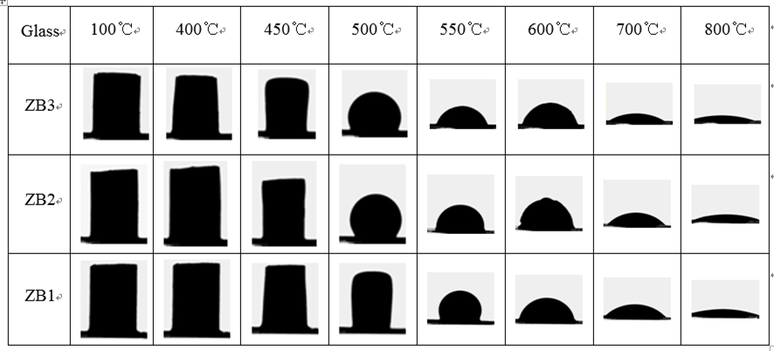
Fig. 1. Shape change of Bi₂O₃–B₂O₃–ZnO glass powder compacts with different compositions as a function of temperature (heating rate of 50 ºC/min).

Fig. 2. Effect of the composition of glass frit on the cell efficiency and sheet resistance.

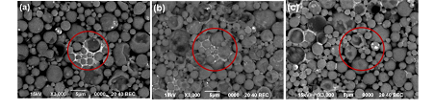
Fig. 3. Surface SEM microstructure of screen-printed Al back contact which are fired at 800ºC : (a) PZB1, (b) PZB2 and (c) PZB3.

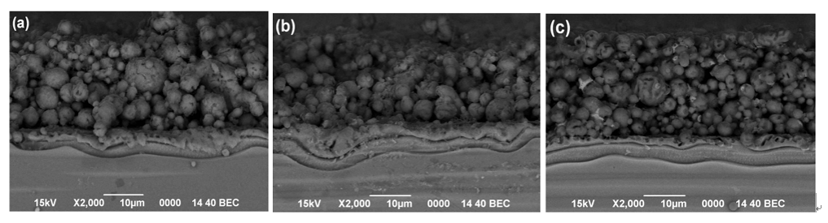
Fig. 4. Cross-sectional back scattered SEM image of screen printed Al back contacts which are fired at 800ºC : (a) PZB1, (b) PZB2 and (c) PZB3.

